Directions: Solve for x and y in the figures.
x = ________

y = ________
x = ________

y = ________
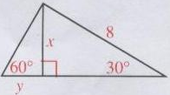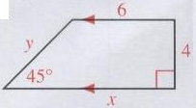

Directions: Sketch the described triangle and label all sides and angles. Calculate the missing two side lengths.
Keep your answers in square root form, do not convert to decimals.

45°-45°-90° Triangle with one leg length 6 30°-60°-90° Triangle with longer leg length 10

Other leg length = _______ Shorter leg length = _______

Hypotenuse length = _______ Hypotenuse length = _______

45°-45°-90° Triangle with hypotenuse length 15 45°-45°-90° Triangle with one leg length $4\sqrt{2}$

Leg length = _______ Other leg length = _______

Other leg length = _______ Hypotenuse length = _______

30°-60°-90° Triangle with hypotenuse length 5 30°-60°-90° Triangle with shorter leg length $6\sqrt{3}$

Shorter leg length = _______ Longer leg length = _______

Longer leg length = _______ Hypotenuse length = _______

